

Club Safeguarding & Welfare Officer Gareth Snelgrove - 07790487689
County Safeguarding & Welfare Officer Ian Griffiths
07463687901
Club/County Safeguarding & Welfare Officer gareth@hagleygolfcoach.co.uk/secretart@worcestershiregolf.com

ABOUT ME

Gareth is PGA Pro & Golf Operations Manager here at Hagley GC. Working closely with PGA Coach, James Green, he is your point of contact for your queries regarding junior safeguarding.

Likewise, if you have any queries regarding adult safeguarding please contact Gareth on the details above.

Thank you.
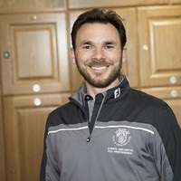

PHOTO

Click to add photo
Alternatively, you can speak to someone at
ChildLine 0800 1111
NSPCC 0808 800 5000
England Golf 01526 351851

